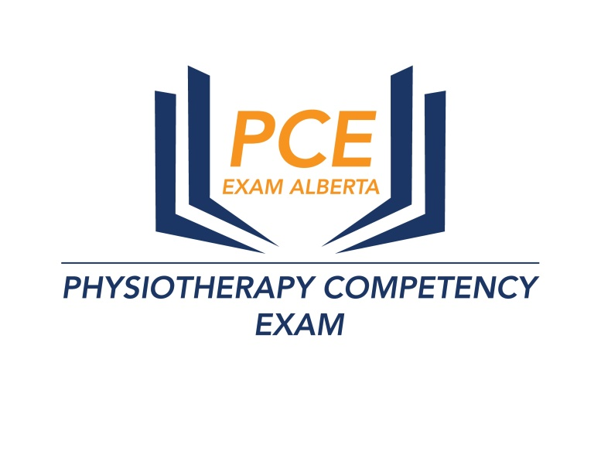

PCE Practical Exam Registration Form – August 16 to November 1 2020
Calgary

Key highlights of this workshop

- Focus on practicing scenarios in every class
- Demonstration of every mock scenario
- mock exams only exclusive for workshop students
- Individual feedback and attention
- Key OSCE competency testing of every student in each class
- Small batch with high student to instructor ratio
- Practise over 100 mock scenarios
- Learn how to complete history taking in 5 minutes, assessments in 10 minutes, hands on techniques, patient education, verbal and non verbal communication for Ortho, Neuro, Cardiopulmonary and Multisystem
- Learn about key safety issues during every mock scenario
- Focus on theory for written stations

- Name

- Address

- Phone

- Email

- Attempt

Course Fee $ 1350
Course Fee Receipts and Course Completion Certificate will be provided

www.pceexamalberta.com/
Phone – 403 992 6558

